Y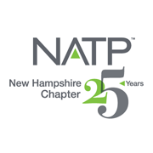 |  | - Upcoming Seminars  May 20, 2021  Oct. 20, 2021  Dec. 2, 2021
NATP – the organization for tax professionals WEBSITE: natptax.com |  | NH Website: NHNATP.com

A MESSAGE FROM OUR PRESIDENT.............

2020 will certainly go down in history as a uniquely challenging year. NH NATP accomplished much considering the complications. We were disappointed to cancel our May seminar, and, as a result, the board chose to offer a live two-day event in October with 11 CPE hours. Virtual federal education is not allowed as it conflicts with the many courses offered by National. The board met via Zoom meetings many times, much more than the norm, in order to accomplish this. The education the Mellems provide is timely, relevant and about the best with well-written material! They did not disappoint, and we received numerous compliments and requests to do more in person events. The Holiday Inn did a superb job creating a COVID-19 resistant environment spacing the tables, seating two to a table. The food was plated and served from behind a plexiglass shield. Masks were mandated and hand sanitizer was available. Participants felt safe and comfortable.

The best laid plans do not always come to fruition and it was apparent that we would not be able to hold a live event in December. This was not a problem because we worked with National to do a webinar for the NH and MA updates. The speakers were excellent: Carollynn Lear, Asst. Commissioner NH Dept of Revenue,,and Sharon Cummings and Virginia Arlington from MA RI Chapter of NATP. Consensus was that the program was a great success with excellent speakers. Sharon Cummings and Virginia Arlington will be offering virtual update seminars in January. Check with the MA RI Chapter webpage for more information and see the article below.

Looking ahead, we are planning events for 2021. We are pleased to announce that Katherine Keane will present May 20, 2021. The board is working on our October 21 and December 2 sessions. At this time, we are anticipating in person events.

The NH NATP Board wishes you a Safe, Happy and Healthy Holiday Season and Profitable New Year. We look forward to seeing you in May.

Betsy Bowen
President

A REVIEW OF THE OCTOBER 8-9, 2020 IN-PERSON SEMINAR
The NH Chapter had an in-person seminar October 8th and 9th at the Holiday Inn in Concord. 25 attended and all 25 thanked us many times for holding this extremely informative event. The Holiday Inn made sure all tables were socially distanced (plus) and only 2 to a table made it very safe. There was hand sanitizer in several locations and all interactive surfaces were wiped down very often. All attendees wore masks when not eating or drinking. We were all extra vigilant. As I said all positive comments were made. Attendees were glad for an in person instead of virtual.
David & Mary Mellem of Wisconsin were our presenters for this day and a half seminar that offered 11 CEs. The topics covered were DEBT CANCELATION, LAWSUITS. OPENING A BUSINESS. CLOSING A BUSINESS. BANKRUPTCY, INHERITED PROPERTY. ETHICS and TAX UPDATE. All topics that are extremely relevant in these COVID times. We all could use the refresher on these subjects as I am sure we will encounter most of these areas in the coming tax year or two.
I am so glad all went smoothly. The board held several zoom meetings throughout the summer deciding whether to hold it. As always, I enjoyed seeing and talking to fellow tax preparers and learning vital info, I know I will use.
Respectfully submitted,
Lynn Annicchiarico
Past President

This is how you said we did on the October 8-9, 2020 Seminar!

Scorecard on the October 2020 Seminar
 | No Rating | 1-3 | 4 | 5 | % responding
Program |  |  |  |  | 4 and/or 5
Debt Collection Cancellation | 1% | 0% | 20% | 78% | 98%
Lawsuits | 0% | 0% | 19% | 80% | 99%
Opening A Business | 1% | 0% | 23% | 76% | 99%
Closing A Business | 5% | 1% | 20% | 5% | 94%
Inherited Property | 1% | 0% | 22% | 77% | 99%
Federal Tax Update | 1% | 1% | 17% | 81% | 98%
Bankruptcy | 2% | 0% | 13% | 84% | 98%
Ethics | 1% | 0% | 11% | 88% | 99%
Comments Were
Love learning with David and Mary
Excellent 2 Days!
Mary made a complex subject understandable

It is quite obvious that the October 8-9 seminar was a resounding success! Kudos to the NH NATP Chapter Education Committee for providing quality education. A lot of work goes into setting up and executing a successful seminar. Everyone who had a part and making this seminar happen deserves a pat on the back, and a good ole “atta boy”.

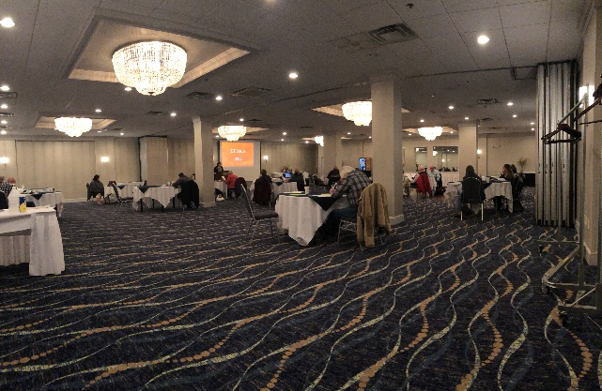
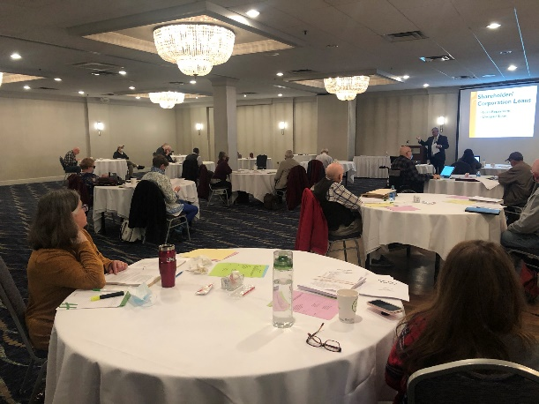
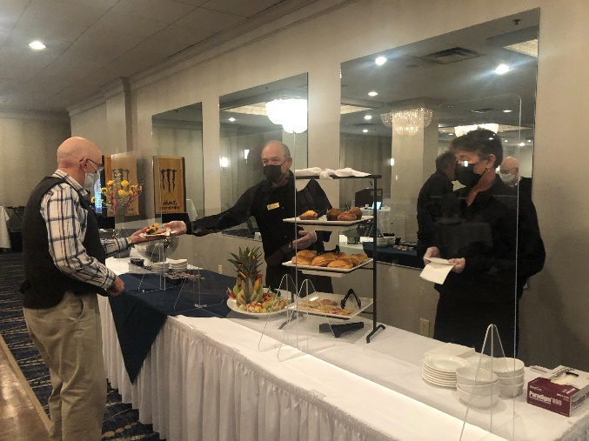
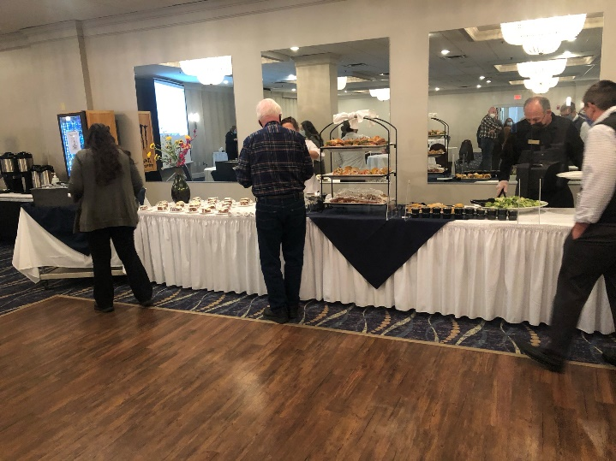

Photos of the October 8-9, 2020 seminar, courtesy of Betsy Bowen, showing COVID-19 safeguards.

Massachusetts State Income Tax for Working from Home In NH

We are following the news on whether NH residents who work from home due to COVID-19 for companies based in MA will be taxed by MA for the income earned in NH. In prior years, out of state residents were only taxed on income earned while working in MA.

The Department’s Non-Resident Income Tax regulation, 830 CMR 62.5A.1, provides, in Section 5(a), the general rules for allocation and apportionment of income to Massachusetts for non-residents working in Massachusetts.
830 CMR 62.5A.3, Massachusetts Source Income of Non-Residents Telecommuting due to the COVID-19 Pandemic, promulgated on October 16, 2020, clarifies the application of these pre-existing Massachusetts source income apportionment rules to non-resident employees who are telecommuting from outside of Massachusetts due to the COVID-19 pandemic. As stated in Section (3)(b) of the regulation, such a non-resident employee must, for the 2020 tax year, determine Massachusetts source income based on either the percentage of the employee’s workdays spent in Massachusetts during the period January 1 through February 29, 2020, or the apportionment percentage properly used to determine the portion of the employee’s wages constituting Massachusetts source income on the employee’s 2019 return.

The case had been sent to the United States Supreme Court.

New Hampshire v. Massachusetts
Pending petition
Docket No. | Argumen | t Opinion | Vote | Author | Term
22O154 | TBD | TBD | TBD | TBD | TBD

Docketed: October 23, 2020
Issue: Whether Massachusetts' tax rule — which subjects nonresident earned income received for services performed outside Massachusetts to the state’s income tax — is unconstitutional confiscation.

We will keep you posted if the status changes.

Granite Tax Connect
On October 7, 2020, the Department of Revenue Administration announced
PHASE 2 IS NOW LIVE! CREATE YOUR ACCOUNT TODAY IF YOU ARE A TAXPAYER OF THE FOLLOWING TAX TYPES:
- Business Profits Tax
- Business Enterprise Tax
- Interest & Dividends Tax
This new system will replace our current e-file system for the above tax types as of January 1, 2021.
What is it?
Our new online portal to manage accounts for taxpayers and tax professionals! Granite Tax Connect allows users to file and amend returns, view balances, make payments, view correspondence, register new accounts, update information and more!
Additionally, without logging in, you can apply for a payment plan, pay from a voucher, look up a license, apply for a Meals & Rentals license and, new in phase two, anonymously report suspected tax fraud, request certifications, such as certificates of good standing and dissolution, and submit a request to add a new, or modify an existing, Power of Attorney.
Phase 1 was launched in October 2019 and made available to taxpayers of the Meals & Rentals Tax, Medicaid Enhancement Tax and Nursing Facility Quality Assessment.
Taxpayers: Don't forget to ask your tax preparers about GTC, you can connect them to your account for even easier filing! Want Updates? Email your name and email address to gtc@dra.nh.gov to make sure you are on the newsletter distribution list.

On November 23, 2020, the Annual Meeting of the NH Chapter was held virtually with the help of folks at National. Prior to the meeting, ballots were emailed to all current members. The results of that balloting, and the slate of officers and directors for the upcoming 2020-2021 year were.

President Elizabeth “Betsy” Bowen, EA
Vice President Susan Merrill-Paul, EA
Treasurer Chris Sawyer, EA
Secretary Norma Boyce, EA

Directors: Kimberly Perkins EA, Anna Houde, Dale Harrington, Walter Kloc and John Preve

Past President, Lynn Annicchiarico will serve as advisor

Carol Romeril who has served as Past President and a long-time Board member has resigned to spend more time with her practice and her family. We thank her for all she has done for the Chapter, and hope to see her at upcoming seminars.

Heard on the street – “My taxes are extremely high because I’m too cheap to pay someone to do my taxes!”

CERTIFYING ACCEPTANCE AGENT (CAA)

A Certifying Acceptance Agent (CAA) is authorized by the Internal Revenue Service (IRS), to assist alien individuals and other foreign persons, who are ineligible or unable to receive Social Security Number (SSN), in obtaining an ITIN (Individual Taxpayer Identification Number) from the IRS. In addition, a CAA is also authorized to submit a Form W-7 on behalf of an applicant, without having to furnish the original documents that support foreign status and identity.

Scott Rosenthal, EA, MBA, a member of the NH Chapter, sent an email to the Board recently regarding a CAA. His email, read, in part:

“While attending a webinar the thought came to me that there could be a market for someone to become a CAA and be able to process ITIN applications. It doesn't make sense for most of us in NH to go through the process of getting certified, once you go through and get certified ($395) you have to submit at least five W-7 applications a year to remain in the program. What I was thinking (all this thinking makes my head hurt) is that I would go through the process if I could be guaranteed that I would get at least the five applications each year. Unlike Block (sorry Susan) I am not looking to have the ITIN applicant become my client, rather to provide the service to my fellow NH NATPers. Might be a good idea to have a few folks, to cover more of the state become certified. Please let me know your thoughts as a Board.”

The Board decided to place an article in the Newsletter to make our members aware of Scott’s proposal. If you are interested, please contact Scott directly at Scott@qtaxllc.com.

Thank you, Scott, for sharing this with the NH membership!

REVIEW OF THE DECEMBER 3, 2020 STATE TAX WEBINAR

This was an awesome webinar that was attended by 34 individuals. It was the first webinar conducted by the NH Chapter (with the help of National), and it went off without a hitch. Kudos are rolling in! Thanks to Betsy Bowen and Dale Harrington of the NH Chapter for providing this webinar. If you missed it, you missed a great one, but a synopsis follows below. Well, maybe a little more than a synopsis! Isn’t it amazing how necessity is the mother of invention? Never would we have thought of remote webinars before Covid-19.

NEW HAMPSHIRE

Carollynn Lear, Assistant Commissioner at the NH Department of Revenue, provided the 34 virtual attendees with a presentation that was jam-packed full of information regarding the happenings and updates at the DOR. The highlights, though very numerous, are listed below.

She mentioned that many DOR personnel are working remotely from home, but they believe this had not caused any disruption of customer service.

87, 365 Business (BET and BPT) and Interest and Dividends tax returns were e-filed in 2019. Interestingly, Interest and Dividend Returns outnumbered the business returns.

She spoke in detail about the most common error which was filing a paper return after the submitting the return through the MeF (Modernized e-Filing) system in the tax software.

New for 2020:
Warehouse Estimated Tax Payments
ACH refunds (instead of paper checks)
Filing of Estimated Tax and Extensions

5,380 grants were awarded amounting to $342 million dollars through the Main Street Relief Fund (MSRF). 5,756 grants were awarded amounting to $40.95 million dollars through the Self-Employed Livelihood Fund (SELF).

IMPORTANT NOTE: State level relief funds received should be included as income for Business filing purposes. Normal operating expenses paid with those funds are deductible. In addition, each recipient must file a report though the Granite Tax Connects (GTC). That report will be ready in January and must be filed by April 15, 2020.

Federal relief funds must be included in income for NH Business Returns, with the exception of loans. Again, appropriate deductions paid with the Federal relief funds are deductible on the NH business return.

Contact www.goferr.nh.gov/covid-expenditures for state questions.

Contact www.irs.gov/coronavirustax-relief-for-businesses-and-tax-exempt-entities for Federal questions.

HB 4, State Budget Bill, provided for a fluctuating rate on the Business Taxes based on state revenues. The rate for 2021 is expected at the end of December.

Reminder – NH does not allow Section 168K Bonus Depreciation or Section 179 expensing.

MASSACHUSETTS

Sharon Cummings and Virginia Arlington, both Massachusetts Chapter NATP members, provided and awesome seminar on MA Income Taxes.

While their presentation focused mainly on preparation of Massachusetts Resident Returns, they did touch on some areas concerning non-residents.

The Commonwealth of Massachusetts has not yet decided many important items relative to the Mass taxes. The subject of taxation of remote out of state workers is nwt at the United States Supreme Court and a docket number has been assigned. Other states have similar situations and are watching closely.

The Massachusetts Chapter of NATP will be holding a 2-day webinar on January 6-7 that will provide updates on the MA, RI, CT, and NY Taxes, as well as a section on Federal Taxes. Once approved (which will be shortly) information will be available at the National website. You can register for the webinar there. In addition, the NH Chapter will provide information on this webinar through its Facebook and Website page. The NH Chapter has been invited to attend.

Massachusetts Department of Revenue has an app MASS TAX CONNECT for filing and paying of individual and business taxes and can be used to manage all tax clients in one place. Register online at http://www.mass.gov/dor/e-services/masstaxconnect.html.

The Massachusetts Department of Revenue can be contacted at 800-392-6089.

At the break between the NH and MA presentations, the raffle was drawn for the free NH Chapter seminar. Winner was Scott Rosenthal. Congratulations!

Submitted by:
Norma Boyce, EA

The NH Chapter of NATP has established an email address so that you can contact your Officers and Directors for Chapter business. It is not meant to be a means to obtain tax information or opinions. However, we welcome your comments and suggestions regarding the activities of the Chapter. We are here to provide you, our members, with a well-run, first-rate organization that provides quality education, and your input is especially important to us. Let us hear from you!
The email address is: NHNATP@yahoo.com
Also, remember to frequently check our Website and Facebook page for updates.

The Officers and Directors want to wish you and your families

And we wish all an easy and profitable tax season!

Your editors,
Norma Boyce, EA and Kimberly Perkins, EA

Keep up to date on the happenings of our Chapter by visiting these websites and FaceBook frequently: www.natptax.com www.nhnatp.com
This Photo by Unknown Author is licensed under CC BY-SA

