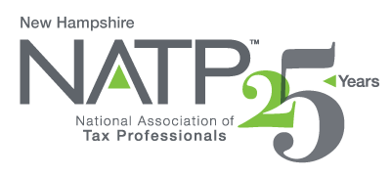
NH NATP WINTER SEMINAR

WHEN: December 5, 2019 8:00 AM to 4:05 PM
WHERE: Holiday Inn, 172 No. Main St., Concord, NH
HOW: Education Packets will be delivered electronically to all attendees registered by December 3, 2019
COST: Before November 29, 2019: Members $100 Non-Members $110
After November 29, 2019: Members $130 Non-Members $145
Paper Materials $25 (request when registering online)

5 CPE hours

Register online at https://natptax.com/Chapters/Pages/NewHampshireChapterEducation.aspx

By Mail: NATP, PO BOX 8002, Appleton, WI 54912

NH Department of Revenue – Peter Colbath, M.S., Tax Auditor, State of NH, Dept. of Revenue
Department of Revenue Updates
Review of Common Errors
Q & A Session

Maine Revenue Services – Jeffrey Bragdon, Tax Section Manager, State of Maine Tax Services
Maine Tax Law Updates
Common Errors on Non-Resident Returns
Q& A Session

NH Charitable Foundation – Richard Peck, VP of Development and Philanthropy Services
Charitable giving solutions that can be used to offer maximum tax benefits
Charitable IRA Rollovers
Triggering events, like stock options, conversions of traditional IRAs to Roth IRAs

Partnerships and Single Member LLCs and Section 199A – John Cunningham, Counsel to McLane Middleton, P.A.
Federal taxation of single member and multi member LLCs
Overview of passthrough deductions under Section 199A
Introductions to key issues under Section 199A
When business owners need Section 199A restructuring
How to develop a Section 199A restructuring plan

REGISTER TODAY! THIS WILL BE ANOTHER GREAT SEMINAR!

