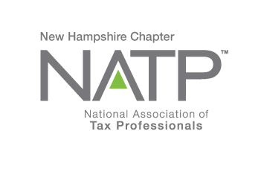
NH NATP DECEMBER SEMINAR

WHEN: December 7, 2017 8:30 AM to 3:00 PM
WHERE: Holiday Inn, 172 No. Main St., Concord, NH
HOW: Education Packets will be delivered electronically to all attendees registered by December 1, 2017
COST: Before December 1, 2017: Members $80 Non-Members $90
After December 1, 2017: Members $110 Non-Members $125

Register online at https://natptax.com/Chapters/Pages/NewHampshireChapterEducation.aspx

By Mail: NATP, PO BOX 8002, Appleton, WI 54912-8002

Topics:

NH Department of Revenue
Always informative, always interesting, sometimes funny, the famous, annual speaker, Peter Colbath, will inform the attendees of all noteworthy happenings at the NH Department of Revenue. He also likes to share some of his experiences with the group. This is always a favorite of our December seminars, and this one is not to be missed either!

Charitable Giving Solutions to Benefit Your Tax Clients
Robert Peck, VP of Development and Philanthropy Services, NH Charitable Foundation will focus on comparing charitable tax deductions for various types of charitable giving vehicles – like donor advised fund or charitable remainder trust; different types of funds at NHCF - like designated fund; and the wide variety of assets that can be contributed to establish them, including cash and different types of non-cash assets - like real estate and securities. The Charitable IRA Rollover option will also be discussed. Lastly, triggering events like exercising employee stock options - and converting a traditional IRA to a Roth IRA - will be discussed, and how making charitable gifts can offset those potential gains. New topic, new speaker – should be a winner!

Understanding Common IRS Penalties
Both Susan Merrill-Paul and the IRS say that penalties are the cornerstone of noncompliance deterrence. From 1955 to present, the number of penalties enforced by the IRS has increased from 14 to more than ten times that. This course can help you understand common IRS penalties and options for obtaining relief from those penalties. Another great topic that is in everyone’s wheelhouse!

3 CE Credits
REGISTER TODAY !

