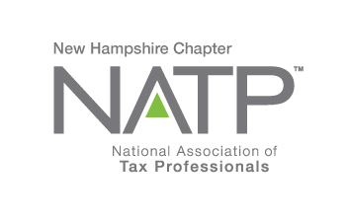
NH NATP SPRING SEMINAR

WHEN: May 24, 2018 8:30 AM to 4:30 PM
WHERE: Holiday Inn, 172 No. Main St., Concord, NH
HOW: Education Packets will be delivered electronically to all attendees registered by May 22, 2018
COST: Before May 20, 2018: Members $135 Non-Members $155
After May 20,2018: Members $155 Non-Members $170
Paper Materials $25 (request when registering online)

Register online at https://natptax.com/Chapters/Pages/NewHampshireChapterEducation.aspx

By Mail: NATP, PO BOX 8002, Appleton, WI 54912-8002

t
DAVID MELLEM, EA – he has 39 years- experience in income tax preparation and over 30 years- experience in tax seminar lecturing. He has spoken to the NH NATP group before, and everyone loved him!
MARY MELLEM, EA – has over 30 years-experience as a tax professional, and over 20 years teaching throughout the country. She, too, has lectured to the NH NATP group.

MARY R

Topics:

FEDERAL TAX UPDATE 3 hours CPE
Discuss the new tax laws, recent revenue rulings, court cases and regulations, etc., and other new items such as mileage rates, per diem amounts, IRS phaseout ranges, etc.

ETHICS 2 hours CPE
Discuss the issues and specific targeted sections of Circular 230, as well as recent court cases involving those sections.

LIKE KIND EXCHANGES 2 hours CPE
This session will explore the qualifications and timing of creating a tax-deferred event, examine the basis of property and the qualified intermediary who holds the funds and facilitates the event and explore reverse exchanges.

LIFE AND REMAINDER INTEREST ISSUES 1 hour CPE
Explore Gift/Estate Tax Consequences, calculation of values, basis of interest and sales before death of donor.

