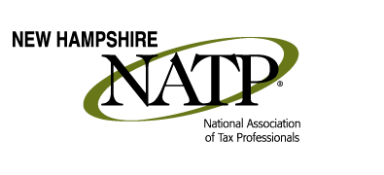
WHAT: NH NATP Spring Education Seminar
WHEN: 8:30 AM – 4:30 PM (Registration starts at 8:00 AM)
WHERE: Holiday Inn, 172 No. Main St., Concord, NH
HOW: Education Packets will be delivered electronically to all attendees registered by May 21st
(Please notify Shirley Perry @ sperry@mdccpas.com if you wish to purchase a printed copy for the seminar)
COST: Before May 21, 2017 Members $125.00 Non-Members $140.00
After May 21, 2017 Members $145.00 Non-Members $160.00
(Lunch included)
This year, we have National Speaker, Kelly Lent-Paul, who some of us know who went to the NATP National Convention in Indianapolis this past summer. It was a privilege to be in her class! She was phenomenal! Kelly has been preparing taxes since 1994, and became an enrolled agent in 1999. She is CFP. And is the director of training for a large franchise. In addition to providing tax and financial services to her client base, she also enjoys teaching tax and financial topics to other professionals. Kelly has her BS from Cornell University and her MBA from St. Bonaventure University. She is a member of NATP, NAEA, FPA and is an active member on the board of directors of her local non-profit organizations. She lives in Western NY with her husband, Jim.
Some highlights about what we’ll be learning:
- Handling Education Credits – who takes them, parent or child? What does Form 1098-T tell you?

- Having trouble reporting those Employee Stock Options?

- Should I stay or should I go? 401K vs IRA?

- RMDs – how much do you know?

- Roth IRAs, including Roth 401K accounts – did you know?

This is going to be a jammed-packed session you won’t want to miss! 8 CE Credits

REGISTER AT NATPTAX.COM AS SOON AS YOU CAN!

