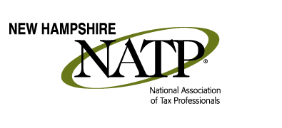
MAY 26, 2016 Seminar
8:45 AM to 4 PM
Registration starts at 8 AM
Holiday Inn, 172 No. Main St., Concord, NH 03301

SPEAKER:
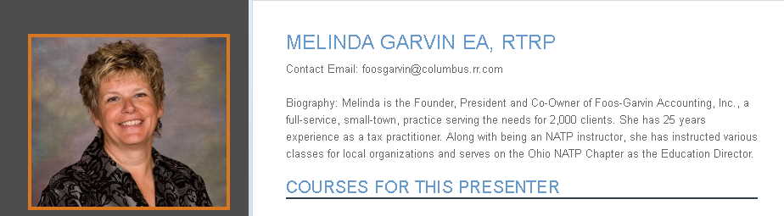

8:45 to 10:25: Affordable Care Act
It's the gift that keeps on giving! Let's look at some scenarios that have come up when the Premium Tax Credit is involved with the everyday life situations of our clients. We will throw in different filing statuses, no insurance, some insurance, divorces, who signs up through the Marketplace and how it makes us want to pull our hair out. Does your software handle it correctly?

10:35 to 12:15: Schedule K-1 and Basis of S Corp Shareholder
Basis is something that is so very important for S Corporation Shareholders - yet so often never kept track of! Why is that? Use this session to learn how to re-construct basis for these clients coming to you with no basis tracking. Learn how to track basis and know where all the Schedule K entries go on the S Corp Shareholder's personal return.

12:15 to 1:00: Lunch will be provided

1:00 to 4:00: Preparing S Corporation Returns
Learn to accurately prepare Form 1120-S, US Income Tax Return for an S Corporation, and the schedules that accompany it. We will do this by actually filling in the forms in the session using a case study so bring your pencils and calculators. Learn how the numbers flow through the various forms and schedules.

All course material will be in electronic form. Please bring pencil, paper and calculator to seminar.

Early Registration: (Last day May 20, 2016) $95 members; $110 non-members
Standard Registration: $115 members; $130 non-members

Register at the National Association of Tax Professionals' website at www.natptax.com

