Y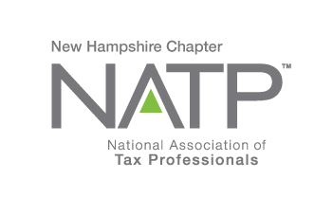 |  | - Upcoming Seminars  Oct. 26, 2017  Dec. 7, 2017
NATP – the organization for tax professionals WEBSITE: natptax.com |  | NH Website: NHNATP.com

NH NATP FALL SEMINAR and ANNUAL MEETING

WHEN: October 26, 2017 8:30 AM to 3:30 PM
WHERE: Holiday Inn, 172 NO. Main St., Concord, NH
HOW: Education Packets will be delivered electronically to all attendees registered by October 20, 2017
COST: Before October 20, 2017: Members $95 Non-Members $110
After October 20, 2017: Members $110 Non-Members $125

Register online at https://natptax.com/Chapters/Pages/NewHampshireChapterEducation.aspx

By Mail: NATP, PO BOX 8002, Appleton, WI 54912-8002

Topics:

IRS Security Summit Updates: Working in partnership with state tax agencies and the tax industry, the IRS has made significant progress against Identity Theft. This session will inform tax professionals of the actions taken by the Security Summit and provide information on new initiatives that targets various fraudulent schemes. Presented by Mary Hanson from the IRS.

Timber Taxes: This program will cover basic documentation and considerations in assessing federal income taxes from timber harvesting. Specifically, we will look at what constitutes a taxable gain, timber basis, timber depletion, a calculator that can help tax professionals determine if there is a financial benefit to depleting timber, and associated documentation. Presented by Andrew Fast, UNH.

Substantiation: Taxpayers are required to keep documentation to substantiate their expenses. The session will discuss what the documentation needs to include. The areas of business deductions like business travel and the “Cohen” rule will be covered, as well as documentation for charitable contributions. Presented by Lynn Annicchiarico, former President of NH NATP.

5 CE Credits

REGISTER TODAY !

_______________________________________________________________________________________________
From our Vice-President Betsy Bowen, EA:
Is Your Colleague Not a Member Yet? Join Today, Save $28
NATP is the leading organization dedicated to tax professionals and the clients they serve.
We encourage you to encourage your colleagues to become part of the NATP family! Not only is Chapter membership included with their general membership, but they’ll also receive access to our expert education, publications and updates, research services, business tools and a community of equally dedicated professionals.
They can become a member today and receive $28 off the regular price of membership.
Use code CHAPTER2017 to receive the discount.
When joining, be sure to include the state Chapter that recruited you in the field that asks, “Who recommended you to NATP?”
If they have any questions, call Member Services at 800.558.3402, ext. 3, or email them at natp@natptax.com.
Membership has benefits: Once you become a member you receive timely newsletters weekly, monthly, and quarterly. Education is provided nationally and through the Chapter in person, online and via recorded webinars. Research services are another great benefit.

And………………..

Testimonial
I recently had the opportunity to attend my third National Convention in Washington DC. NATP brings together tax professionals from various fields associated with taxes: Tax Professionals, Enrolled Agents, CPA’s, Accountants, Attorneys and Financial Planners who teach a plethora of courses associated with taxes. This provides the opportunity to look at taxes from various perspectives enabling a more complete view of the tax picture.

We had the opportunity to network with professionals from the various professions. I met two EA’s from South Carolina who took the opportunity to attend our convention. They were amazed with the quality and diversity of the education and plan to attend in the future.

PHISHING
The Internal Revenue Service issued a new warning Tuesday to users of its online e-Services cautioning them to beware of a new phishing scam that attempts to trick tax professionals into “signing” a new e-Services user agreement.
The phishing scam is actually trying to steal passwords and data, the IRS warned in an email to tax professionals. The IRS has been trying to migrate to new e-Services technology with improved authentication and security abilities, but has faced repeated delays. The IRS said that all tax professionals should be aware that as e-Services begins its move later this month to Secure Access authentication and its two-factor protections, cybercriminals are likely to make last-ditch efforts to steal passwords and data prior to the transition.
The swindle email claims to come from “e-Services Registration” and says “Important Update about Your e-Services Account” in the subject line. In part, the scam email states, “We are rolling out a new user agreement and all registered users must accept its revised terms to have access to e-Services and its products.” The email asks users to review and accept the agreement but takes them instead to a fake site.
If tax professionals have clicked on this link, the IRS said they should perform a deep scan with their security software, contact their office’s IT or cybersecurity personnel, and contact the IRS’s e-Help Desk.
Separately on Tuesday, the IRS said the migration of e-Services to a new platform is taking longer than anticipated. “We know this is causing issues for some of you, and we apologize,” said the IRS. “We are working hard to get this technology upgrade in place and hope to have applications back online within the next two weeks. We will provide weekly updates until we are ready to launch.”
Meanwhile, the IRS’s online Transcript Delivery System, Taxpayer Identification Number Matching, Secure Object Repository and Registration apps are functional, it noted. (Reprinted, with permission, from TaxPro Today, October 10, 2017)

And you wondered why you had a headache………….
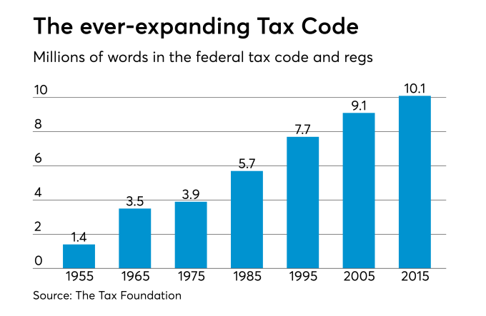
________________________________________________________________________________________________
PTIN REMINDER

In the next few days, we will begin accepting Preparer Tax Identification Number (PTIN) renewals for 2018. We will send another e-mail once renewal season officially opens.

In the meantime, we want to remind you that while you are required to provide an e-mail address for PTIN communications, the e-mail address is not required to be your company e-mail. It only has to be an e-mail account that you check regularly for PTIN communications.

If you have concerns about the misuse of your company e-mail, any increased potential for identity theft related to your e-mail, or cyber intrusions and scams related to your e-mail, please know that you are not required to use your company e-mail address on your PTIN account. Again, you are only required to provide an e-mail address that you check regularly for PTIN communications. It can be ANY e-mail address, but the e-mail address you provide WILL be included in published PTIN listings.

If you want to change the email address on your PTIN account, select "Edit Login Information" at the top right corner of the Main Menu and follow the prompts.

Thank you for your contributions to effective tax administration and I hope this information is helpful.

Carol A. Campbell
Director, Return Preparer Office
Internal Revenue Service

As most of the Officers and Directors are busy at this time with extensions, I am going to step in for them and tell you how much we value you as a member of NH NATP and want your chapter to meet your needs. Everyone that serves on the Board does so with you, the member, and your needs, as the first priority. We hope the education provided and the networking with peers is useful and valuable to you. You are encouraged to communicate any comments or suggestions to any Board member to enhance your experience with the NH Chapter. You can easily find them -they walk around with name badges on. Approach any one of them at a seminar, or email me directly, and I will forward it to the Board. We, as your Board, simply drive the bus, but it is you, the member, who puts the fuel in the tank to make the bus go!
On another note, please remember that we are always looking for members to serve as Officers and Directors of the Board. You will find the Board a warm and friendly bunch. We are all in this to help one another, so no one position is overburdened. Feel free to join us at a Board meeting. Come see what we are all about! One Board meeting is being held after the October seminar ends, and another after the December seminar ends. Won’t you join us?
We sincerely hope you find the upcoming seminars useful and helpful for the upcoming tax season and beyond. And again, thank you for your participation!

Your Newsletter Editor,
Norma Boyce
NBoyce33@gmail.com
Secretary
NH NATP

Keep up to date on the happenings of our Chapter by visiting the National and local Chapter Websites frequently:
www.natptax.com www.nhnatp.com

That’s it for now, folks!

