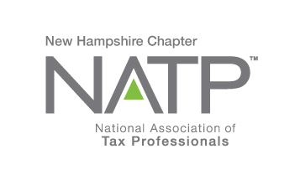
NH NATP FALL SEMINAR AND ANNUAL MEETING

WHEN: October 25, 2018 8:00 AM to 5:05 PM
WHERE: Holiday Inn, 172 No. Main St., Concord, NH
HOW: Education Packets will be delivered electronically to all attendees registered by October 20, 2018
COST: Before October 20, 2018: Members $135 Non-Members $150
After October 20,2018: Members $155 Non-Members $170
Paper Materials $25 (request when registering online)

Register online at https://natptax.com/Chapters/Pages/NewHampshireChapterEducation.aspx

By Mail: NATP, PO BOX 8002, Appleton, WI 54912-8002

t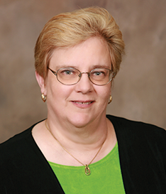
Our instructor, Jaye Tritz, EA, CFP, holds a B.A. from Northwestern University, and is currently a multi-unit franchise owner with H&R Block in the southeast Wisconsin area. She has been preparing taxes since 1992, having earned her Enrolled Agent designation in 1997. She became a NTPI fellow in 2010. Jaye’s practice provides tax preparation, representation, business services, and financial planning for approximately 3,700 clients. She also conducts seminars.
MARY R
Topics:

Choice of Business Entity and Revocation of S-Corporation Status 2 hours CPE

Understanding QBI and the Section 199A Deduction 3 hours CPE

Tax Reform for Individuals and the New Form 1040 2 hours CPE

==================================================================

MARY HANSON, IRS Senior Stakeholder Liaison officer,
DATA SECURITY AND IDENTITY THEFT 1 hour CPE

ANNUAL MEETING AND ELECTION OF OFFICERS

